**Detailed Business Specific Requirements:-**

**Theme**: Water Utilization

**Applications**: **Irrigation Management**

**Use Cases:-** Command Area-**IM-CA-02**

**Other linked Use Case :-** Digital Hydro Infrastructure, Forecasted availability, Current Availability, Command area demand, New schemes, Crop production, Irrigation modernization plans, Benchmarking of irrigation projects, Performance Evaluation Studies, Water logging and Salinity, Mobile App for Irrigation Management.

**Description**:- Irrigation project comprises of the head works (storage or diversion dam), canal and distribution network in the command area for irrigation supplies to the command farmers. The size of the command area is worked out on the basis of water availability and water demand based on the cropping pattern approved by the agronomist, which varies from project to project. Efforts are make to optimize to give higher production and to maximize production per drop of water. The boundary of the command area is fixed based on the topography and other factors.

**Reframe:** An irrigation project includes essential components such as headworks (either a storage or diversion dam), canals, and a distribution network designed to supply irrigation water to farmers within the designated command area. The size of this command area is determined by assessing water availability and demand, which is influenced by the cropping Pattern, approved by the agronomist and may vary from one project to another. The project aims to optimize water usage to enhance agricultural productivity and maximize output per unit of water consumed. Additionally, the boundaries of the command area are established based on topographical features and other relevant factors.

**Use Case Of Description:**

**Use Case: Irrigation Project Management**

**Use Case Name:** Irrigation Project Management

**Actors:**

* Project Manager
* Agronomist
* Water Resource Engineer
* Field Technician
* Farmers

**Description:**

This use case involves the planning, implementation, and management of an irrigation project, which includes head works (storage or diversion dam), canals, and a distribution network to supply irrigation water to farmers within the command area.

**Preconditions:**

* Water availability and demand assessments have been conducted.
* The cropping pattern has been approved by the agronomist.
* The project design has been finalized.

**Post conditions:**

* An efficient irrigation system is established, providing adequate water supply to the command area.
* Increased agricultural productivity and optimized water usage.

**Main Flow:**

1. **Assess Water Availability**: The project manager collaborates with the water resource engineer to evaluate the available water sources.
2. **Determine Water Demand**: The agronomist analyzes the cropping pattern to estimate the water demand for the command area.
3. **Define Command Area**: The project team establishes the boundaries of the command area based on topography and other relevant factors.
4. **Design Irrigation System**: The water resource engineer designs the head works, canal, and distribution network to meet the identified water needs.
5. **Implement Project**: The field technician oversees the construction and installation of the irrigation infrastructure.
6. **Monitor System Performance**: The project manager and field technician regularly monitor the irrigation system to ensure efficient water distribution.
7. **Optimize Water Use**: The agronomist and project manager work together to implement strategies that maximize agricultural production per unit of water used.
8. **Gather Feedback from Farmers**: Farmers provide input on the effectiveness of the irrigation system and any challenges faced.

**Alternative Flows:**

* If water availability is insufficient, the project team may need to revise the design or seek alternative water sources.

**Use Case Benefits:**

* Ensures efficient water management and distribution for agricultural purposes.
* Enhances crop yields and optimizes water usage, contributing to sustainable farming practices.
* Facilitates collaboration among various stakeholders, including engineers, agronomists, and farmers.

This use case highlights the critical steps involved in managing an irrigation project, emphasizing the importance of planning, collaboration, and optimization in achieving successful agricultural outcomes.

**Summary:** The use case for irrigation project management involves a collaborative approach among key stakeholders, including project managers, agronomists, water resource engineers, field technicians, and farmers, to effectively plan, implement, and oversee an irrigation system. The process begins with assessing water availability and determining water demand based on approved cropping patterns, followed by defining the command area boundaries and designing the necessary infrastructure, such as head works, canals, and distribution networks. The project emphasizes monitoring system performance and optimizing water usage to enhance agricultural productivity while gathering feedback from farmers to ensure the system meets their needs. Overall, this use case highlights the importance of strategic planning and collaboration in achieving successful irrigation outcomes.

**Figure 001_Intro_UseCase_PlantUML**

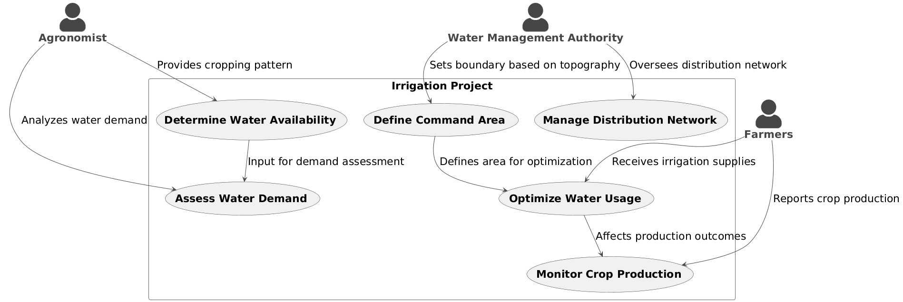

**Code For Figure 001_Intro_UseCase_PlantUML**

@startuml

!theme vibrant

skinparam actorstyle awesome

skinparam defaultfontsize 22

actor "**Agronomist**" as Agronomist

actor "**Farmers**" as Farmers

actor "**Water Management Authority**" as WMA

RECTANGLE "Irrigation Project" {

usecase "**Determine Water Availability**" as UC1

usecase "**Assess Water Demand**" as UC2

usecase "**Define Command Area**" as UC3

usecase "**Optimize Water Usage**" as UC4

usecase "**Manage Distribution Network**" as UC5

usecase "**Monitor Crop Production**" as UC6

}

Agronomist --> UC1 : "Provides cropping pattern"

Agronomist --> UC2 : "Analyzes water demand"

WMA --> UC3 : "Sets boundary based on topography"

Farmers --> UC4 : "Receives irrigation supplies"

WMA --> UC5 : "Oversees distribution network"

Farmers --> UC6 : "Reports crop production"

UC1 --> UC2 : "Input for demand assessment"

UC3 --> UC4 : "Defines area for optimization"

UC4 --> UC6 : "Affects production outcomes"

@enduml

**Figure 001_Intro_UseCaseFlow_NapkinAI**

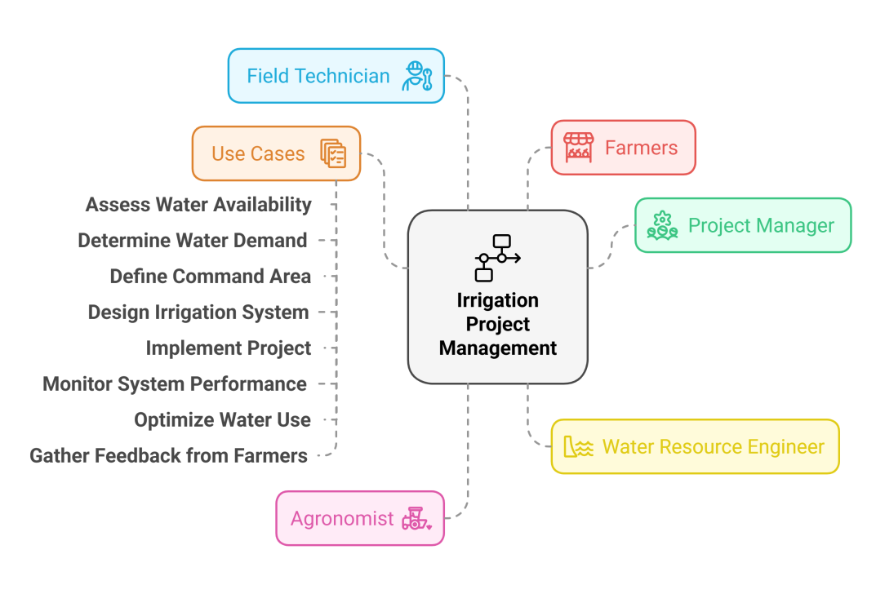

**Figure 001_Intro_FlowChart_MermaidChart_With Mermaid Code**

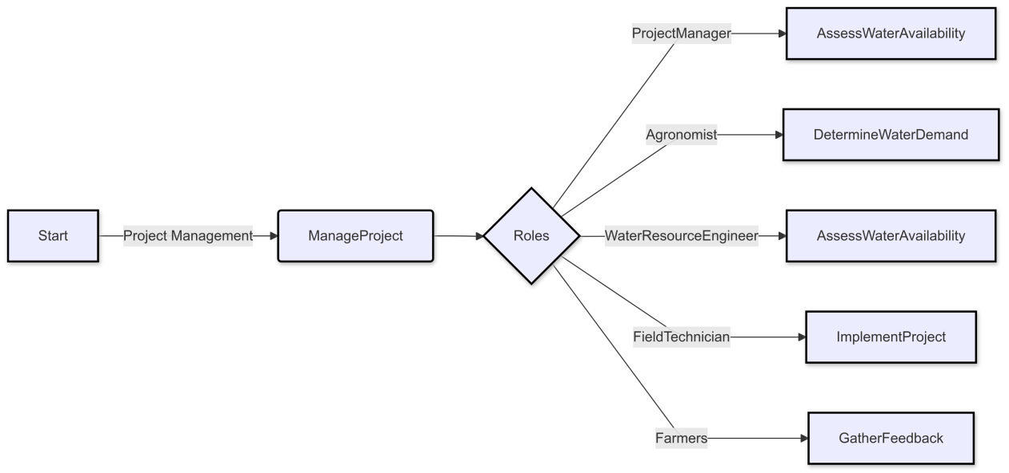

**Code For Figure 001_Intro_FlowChart_NoteGPT_With Mermaid Code**

---

config:

  layout: dagre

  theme: default

---

**flowchart** LR

    A["Start"] **--** Project Management **-->** B("ManageProject")

    B **-->** C{"Roles"}

    C **--** ProjectManager **-->** D["AssessWaterAvailability"]

    C **--** Agronomist **-->** J["DetermineWaterDemand"]

    C **--** WaterResourceEngineer **-->** N["AssessWaterAvailability"]

    C **--** FieldTechnician **-->** Q["ImplementProject"]

    C **--** Farmers **-->** S["GatherFeedback"]

    style A stroke:#000000,stroke-width:2px,stroke-dasharray: 0

    style B stroke-width:2px,stroke-dasharray: 0,stroke:#000000

    style C stroke:#000000,stroke-width:2px,stroke-dasharray: 0

    style D stroke:#000000,stroke-width:2px,stroke-dasharray: 0

    style J stroke:#000000,stroke-width:2px,stroke-dasharray: 0

    style N stroke:#000000,stroke-width:2px,stroke-dasharray: 0

    style Q stroke:#000000,stroke-width:2px,stroke-dasharray: 0

    style S stroke:#000000,stroke-width:2px,stroke-dasharray: 0

**Used By (End Users):-** Planners, Decision makers, State WRDs, CWC, Farmers Associations

**Figure 002_EndUsers_UseCase_PlantUML**

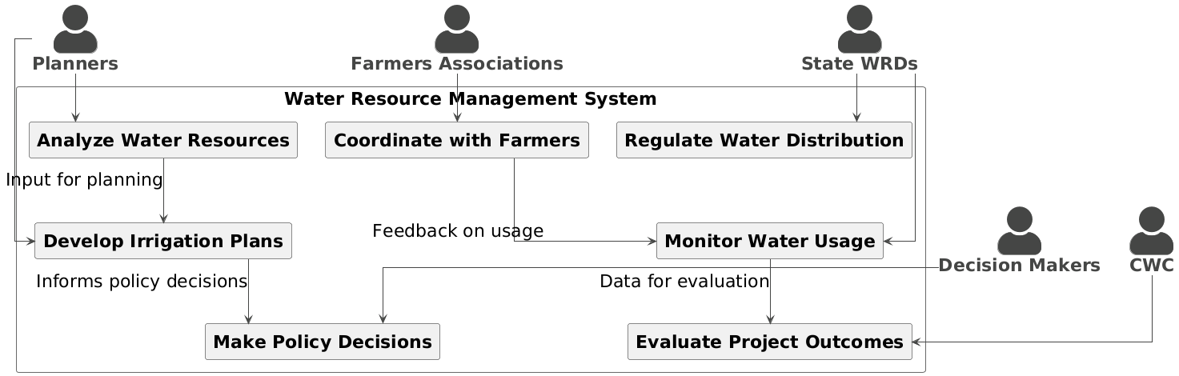

**Code For Figure 002_EndUsers_UseCase_PlantUML**

@startuml

!theme vibrant

skinparam linetype ortho

skinparam actorstyle awesome

skinparam defaultfontsize 22

actor "**Planners**" as Planners

actor "**Decision Makers**" as DecisionMakers

actor "**State WRDs**" as StateWRDs

actor "**CWC**" as CWC

actor "**Farmers Associations**" as FarmersAssociations

RECTANGLE "Water Resource Management System" {

rectangle "**Analyze Water Resources**" as UC1

rectangle "**Develop Irrigation Plans**" as UC2

rectangle "**Make Policy Decisions**" as UC3

rectangle "**Monitor Water Usage**" as UC4

rectangle "**Coordinate with Farmers**" as UC5

rectangle "**Evaluate Project Outcomes**" as UC6

rectangle "**Regulate Water Distribution**" as UC7

}

Planners --> UC1

Planners --> UC2

DecisionMakers --> UC3

StateWRDs --> UC4

StateWRDs --> UC7

CWC --> UC6

FarmersAssociations --> UC5

UC1 --> UC2 : "Input for planning"

UC2 --> UC3 : "Informs policy decisions"

UC4 --> UC6 : "Data for evaluation"

UC5 --> UC4 : "Feedback on usage"

@enduml

**Figure 002_EndUsers_UseCaseFlow_NapkinAI**

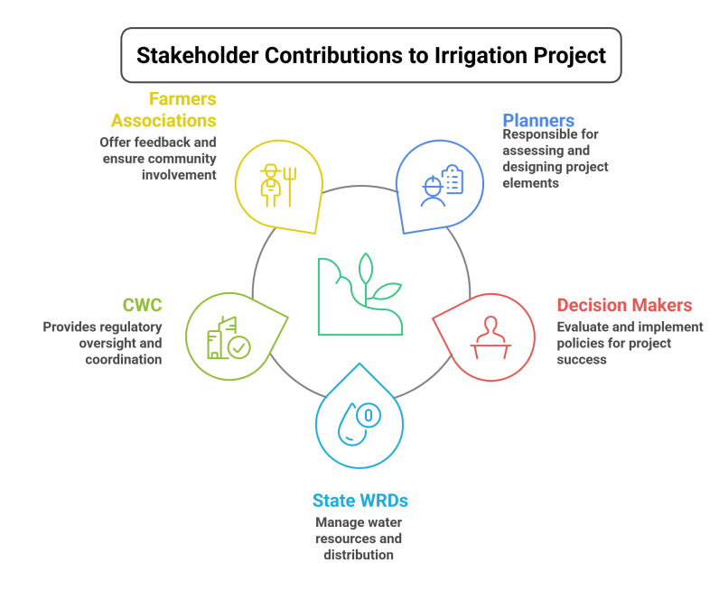

**Figure 002_EndUsers_FlowChart_PlantUML**

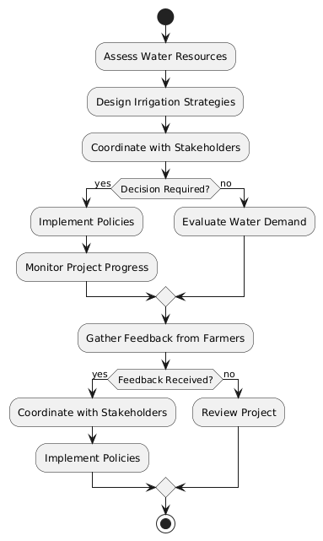

**Code For Figure 002_EndUsers_FlowChart_PlantUML**

@startuml

Start

:Assess Water Resources;

:Design Irrigation Strategies;

:Coordinate with Stakeholders;

if (Decision Required?) then (yes)

:Implement Policies;

:Monitor Project Progress;

else (no)

:Evaluate Water Demand;

endif

:Gather Feedback from Farmers;

if (Feedback Received?) then (yes)

:Coordinate with Stakeholders;

:Implement Policies;

else (no)

:Review Project;

endif

stop

@enduml

**Priority**:- **High Priority :** This use case is the base for proper implementation of irrigation management for enhancing the food production in the country. Command Area component of an irrigation project governs the irrigation potential. Therefore, higher the coverage of command areas, higher will be the irrigation potential and more will be the enhancement in food security scenario.

**Reframe:** This use case serves as the foundation for effective irrigation management aimed at increasing food production in the country. The command area component of an irrigation project plays a crucial role in determining irrigation potential. Consequently, a greater coverage of command areas leads to enhanced irrigation potential, which significantly contributes to improving food security.

**UseCase of Priority:**

**Use Case: Enhancing Food Production through Command Area Management**

**Use Case Name: Enhancing Food Production through Command Area Management**

**Actors:**

* Irrigation Manager
* Agronomist
* Policy Maker
* Farmers
* Data Analyst

**Description:**

This use case involves the strategic management of command areas within irrigation projects to maximize irrigation potential and enhance food production, thereby improving food security in the country.

**Pre conditions:**

* Existing irrigation projects with defined command areas.
* Availability of data on current irrigation coverage and agricultural productivity.

**Post conditions:**

* Increased coverage of command areas leading to improved irrigation potential.
* Enhanced food production and food security in the region.

**Main Flow:**

1. **Assess Current Command Area Coverage:** The irrigation manager and data analyst evaluate the existing command area coverage and its effectiveness in irrigation.
2. **Identify Gaps:** The team identifies areas with insufficient irrigation coverage and potential for expansion.
3. **Develop Management Strategies:** The agronomist collaborates with the irrigation manager to develop strategies for optimizing command area management, including infrastructure improvements and resource allocation.
4. **Engage Stakeholders:** The policy maker engages with farmers and local communities to discuss the importance of expanding command areas and gather input on potential challenges.
5. **Implement Strategies:** The irrigation manager oversees the implementation of the developed strategies, ensuring that resources are allocated effectively.
6. **Monitor and Evaluate:** The data analyst monitors the impact of the changes on irrigation potential and food production, collecting data for evaluation.
7. **Adjust Strategies as Needed:** Based on monitoring results, the team adjusts strategies to further enhance command area management and food production.

**Alternative Flows:**

* If challenges arise during implementation, the team may need to reassess strategies and engage in additional stakeholder consultations.

**Use Case Benefits:**

* Maximizes irrigation potential through effective command area management.
* Increases food production, contributing to improved food security.
* Fosters collaboration among stakeholders, ensuring that local needs and insights are considered.

This use case highlights the critical role of command area management in enhancing food production and food security through effective irrigation practices.

**Summary:** The use case for enhancing food production through command area management focuses on the strategic oversight of irrigation projects to maximize irrigation potential and improve food security in the country. Involving key stakeholders such as irrigation managers, agronomists, policy makers, farmers, and data analysts, the process begins with assessing current command area coverage and identifying gaps for expansion. Management strategies are developed collaboratively to optimize resource allocation and infrastructure improvements, followed by stakeholder engagement to address local needs and challenges. The implementation phase is monitored and evaluated to measure the impact on irrigation potential and food production, allowing for adjustments as necessary. Overall, this use case underscores the importance of effective command area management in increasing agricultural output and ensuring food security.

**Figure 003_Priority_UseCase_PlantUML**

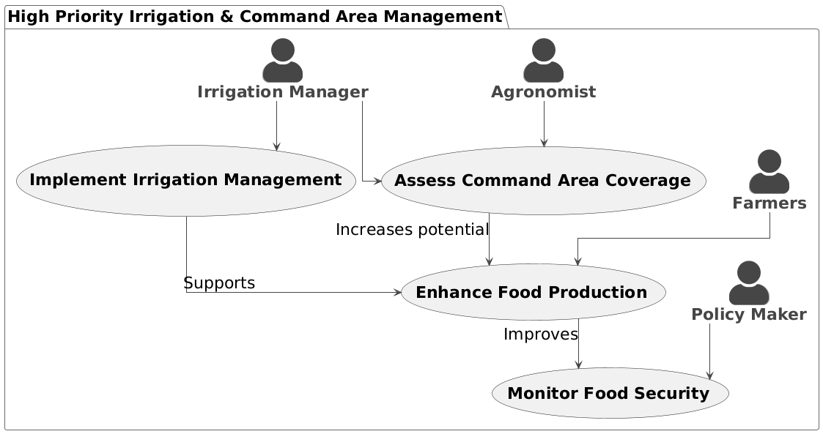

**Code For Figure 003_Priority_UseCase_PlantUML**

@startuml

!theme vibrant

skinparam linetype ortho

skinparam actorstyle awesome

skinparam defaultfontsize 22

Package "High Priority Irrigation & Command Area Management" {

actor "**Irrigation Manager**" as IrrigationManager

actor "**Farmers**" as Farmers

actor "**Agronomist**" as Agronomist

actor "**Policy Maker**" as PolicyMaker

usecase "**Implement Irrigation Management**" as UC1

usecase "**Assess Command Area Coverage**" as UC2

usecase "**Enhance Food Production**" as UC3

usecase "**Monitor Food Security**" as UC4

}

IrrigationManager --> UC1

IrrigationManager --> UC2

Farmers --> UC3

Agronomist --> UC2

PolicyMaker --> UC4

UC1 --> UC3 : "Supports"

UC2 --> UC3 : "Increases potential"

UC3 --> UC4 : "Improves"

@enduml

**Figure 003_Priority_UseCaseFlow_NapkinAI**

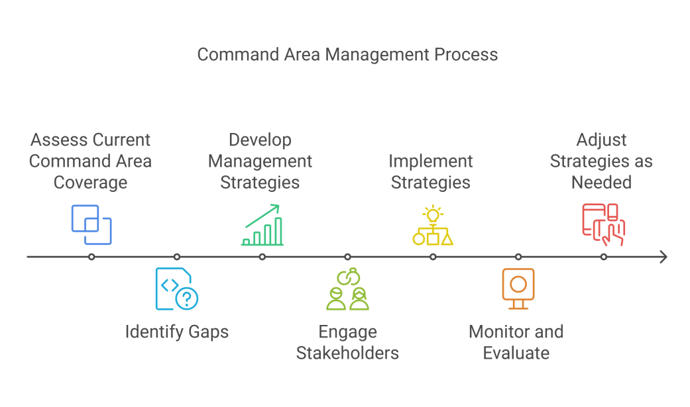

**Figure 003_Priority_FlowChart_NoteGPT_With MermaidCode**

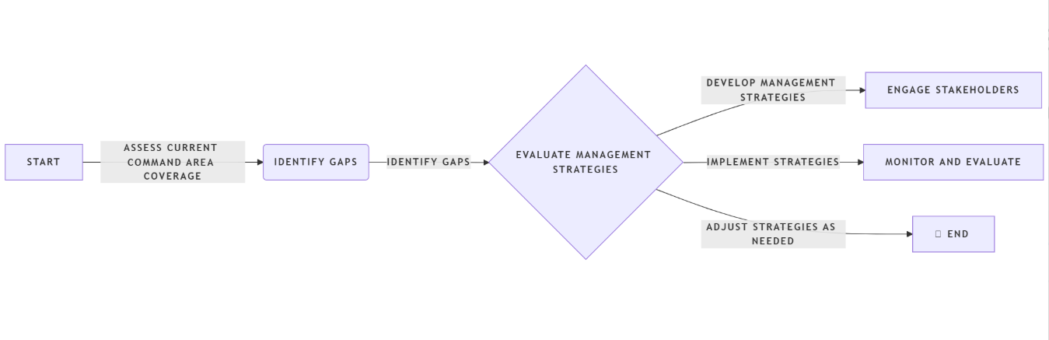

**Code For Figure 003_Priority_FlowChart_NoteGPT_With MermaidCode**

flowchart LR

A[Start] --Assess Current Command Area Coverage--> B(Identify Gaps)

B --Identify Gaps--> C{Evaluate Management Strategies}

C --Develop Management Strategies--> D[Engage Stakeholders]

C --Implement Strategies--> E[Monitor and Evaluate]

C --Adjust Strategies as Needed--> F[fa:fa-car End]

**Phase:-** **Phase**  **2:** DSS Development of IWCIMS

**Governance Need (Business Problem):-**

**Issue**:- :During planning and formulation of any irrigation project, the command area so available has to be nearer to the project head works (i.e., source of water) and has also to be suitable for sustained irrigation.

**Reframe:** When planning and formulating an irrigation project, it is essential that the available command area is located close to the project head works (the water source) and is also suitable for sustained irrigation.

**Use Case of Govt. Need:**

**Use Case: Planning Command Area for Irrigation Projects**

**Use Case Name:** Planning Command Area for Irrigation Projects

**Actors:**

* Project Planner
* Water Resource Engineer
* Agronomist
* Environmental Analyst
* Stakeholder Representatives

**Description:**

This use case involves the assessment and planning of the command area for an irrigation project to ensure it is located near the project head works (water source) and is suitable for sustained irrigation.

**Preconditions:**

* Preliminary data on water sources and topography is available.
* Stakeholder input has been gathered regarding local agricultural needs.

**Post conditions:**

* A well-defined command area that is both accessible to the water source and suitable for sustained irrigation is established.

**Main Flow:**

1. **Gather Preliminary Data**: The project planner collects data on potential water sources and existing land use in the vicinity.
2. **Identify Suitable Locations**: The water resource engineer analyzes the data to identify locations for the command area that are close to the project head works.
3. **Assess Soil and Environmental Conditions**: The agronomist and environmental analyst evaluate soil quality and Environmental factors to ensure the area are suitable for sustained irrigation.
4. **Engage Stakeholders**: Stakeholder representatives are consulted to gather input on local agricultural practices and needs.
5. **Finalize Command Area Design**: Based on the assessments and stakeholder feedback, the project planner finalizes the design of the command area.
6. **Document Findings**: All findings and decisions are documented for future reference and project implementation.

**Alternative Flows:**

* If the initial assessments reveal unsuitable conditions, the team may need to revisit potential locations and conduct further analysis.

**Use Case Benefits:**

* Ensures that the command area is optimally located for efficient water delivery and agricultural productivity.
* Promotes sustainable irrigation practices by considering environmental and soil conditions.
* Facilitates stakeholder engagement, ensuring that local needs and insights are incorporated into the planning process.

This use case highlights the importance of careful planning and assessment in establishing a command area that supports effective irrigation management and agricultural sustainability.

**Summary:**

The use case for planning the command area for irrigation projects focuses on the assessment and strategic selection of a command area that is both close to the project head works (water source) and suitable for sustained irrigation. Involving key stakeholders such as project planners, water resource engineers, agronomists, environmental analysts, and stakeholder representatives, the process begins with gathering preliminary data on water sources and land use. The team identifies suitable locations, evaluates soil and environmental conditions, and engages stakeholders to incorporate local agricultural needs and practices. The final design of the command area is documented, ensuring that it is optimally positioned for efficient water delivery and agricultural productivity while promoting sustainable irrigation practices. This use case underscores the critical role of thorough planning and stakeholder engagement in establishing effective irrigation management.

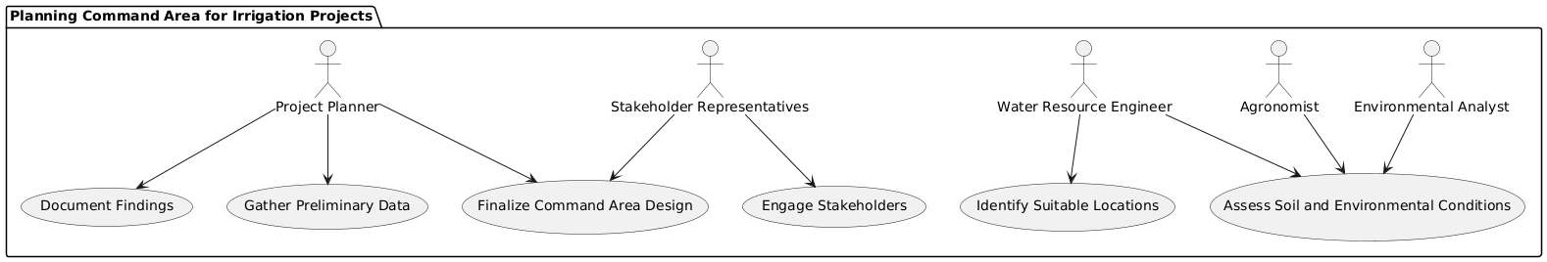**Figure 004_Govt. Need_Usecase_PlantUML**

**Code for Figure 004_Govt.Need_Usecase_PlanUML**

@startuml

package "Planning Command Area for Irrigation Projects" {

actor "Project Planner" as PP

actor "Water Resource Engineer" as WRE

actor "Agronomist" as AG

actor "Environmental Analyst" as EA

actor "Stakeholder Representatives" as SR

usecase "Gather Preliminary Data" as UCA1

usecase "Identify Suitable Locations" as UCA2

usecase "Assess Soil and Environmental Conditions" as UCA3

usecase "Engage Stakeholders" as UCA4

usecase "Finalize Command Area Design" as UCA5

usecase "Document Findings" as UCA6

PP --> UCA1

PP --> UCA5

PP --> UCA6

WRE --> UCA2

WRE --> UCA3

AG --> UCA3

EA --> UCA3

SR --> UCA4

SR --> UCA5

}

@enduml

**Figure 004_Govt. Need_UsecaseFlow_NapkinAI**

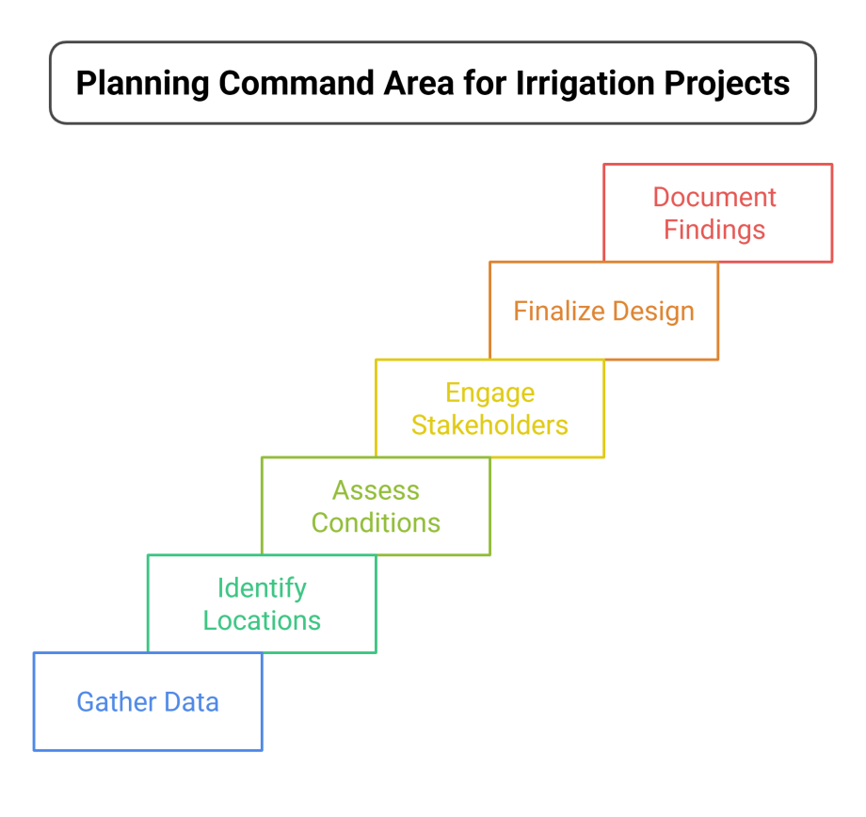

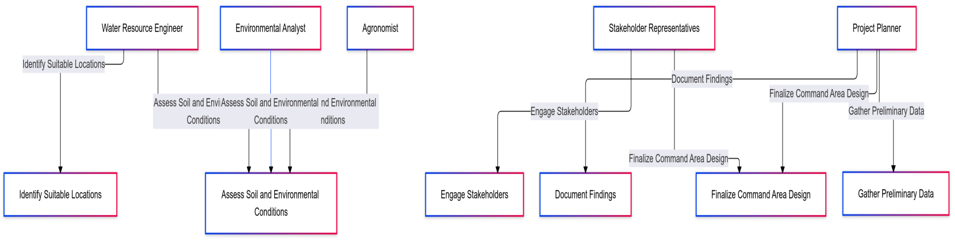**Figure 004_Govt. Need_MermaidChart_With Mermaid Code**

**Figure 004_Govt. Need_FlowChart_NoteGPT_With MermaidCode**

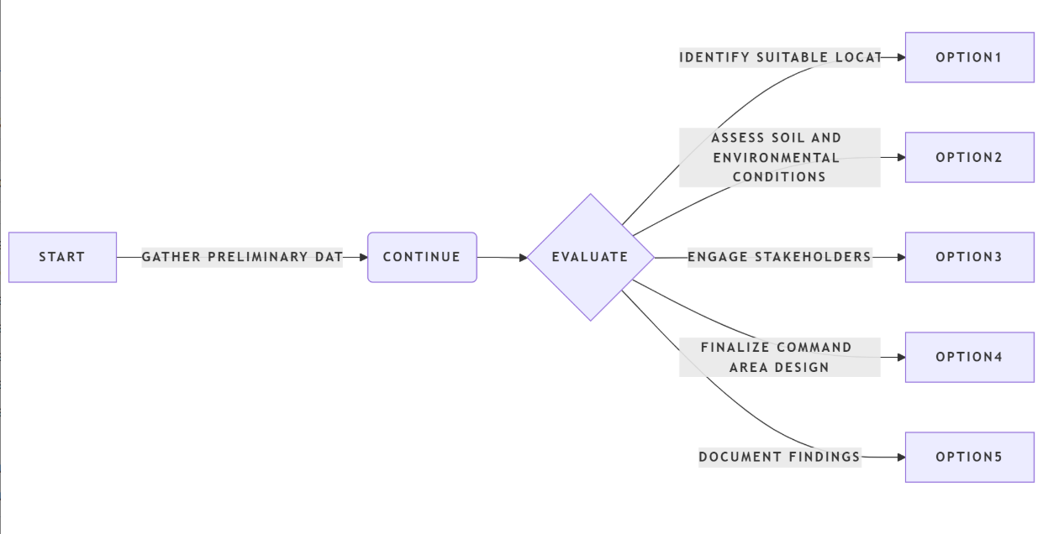

**Code For Figure 004_Govt. Need_FlowChart_NoteGPT_With MermaidCode**

flowchart LR

A[Start] --Gather Preliminary Data--> B(Continue)

B --> C{Evaluate}

C --Identify Suitable Locations--> D[Option1]

C --Assess Soil and Environmental Conditions--> E[Option2]

C --Engage Stakeholders--> F[Option3]

C --Finalize Command Area Design--> G[Option4]

C --Document Findings--> H[Option5]

**Code For Figure 004_Govt. Need_MermaidChart_NoteGPT_With Mermaid Code**

---

config:

  layout: fixed

  theme: mc

---

**flowchart** TD

    PP["Project Planner"] **--** Gather Preliminary Data **-->** UCA1["Gather Preliminary Data"]

    PP **--** Finalize Command Area Design **-->** UCA5["Finalize Command Area Design"]

    PP **--** Document Findings **-->** UCA6["Document Findings"]

    WRE["Water Resource Engineer"] **--** Identify Suitable Locations **-->** UCA2["Identify Suitable Locations"]

    WRE **--** Assess Soil and Environmental Conditions **-->** UCA3["Assess Soil and Environmental Conditions"]

    AG["Agronomist"] **--** Assess Soil and Environmental Conditions **-->** UCA3

    EA["Environmental Analyst"] **--** Assess Soil and Environmental Conditions **-->** UCA3

    SR["Stakeholder Representatives"] **--** Engage Stakeholders **-->** UCA4["Engage Stakeholders"]

    SR **--** Finalize Command Area Design **-->** UCA5

    style PP stroke-width:2px,stroke-dasharray: 0,color:#000000

    style UCA1 stroke-width:2px,stroke-dasharray: 0,color:#000000

    style UCA5 stroke-width:2px,stroke-dasharray: 0,color:#000000

    style UCA6 stroke-width:2px,stroke-dasharray: 0,color:#000000

    style WRE color:#000000,fill:#FFFFFF,stroke-width:2px,stroke-dasharray: 0

    style UCA2 stroke-width:2px,stroke-dasharray: 0,color:#000000

    style UCA3 stroke-width:2px,stroke-dasharray: 0,color:#000000

    style AG stroke-width:2px,stroke-dasharray: 0,color:#000000

    style EA stroke-width:2px,stroke-dasharray: 0,color:#000000

    style SR stroke-width:2px,stroke-dasharray: 0,color:#000000

    style UCA4 stroke-width:2px,stroke-dasharray: 0,color:#000000

    linkStyle 6 stroke:#2962FF

**Approach**:- it is necessary to carry out soil survey and agro meteorological studies in the command area to establish the soil suitability and land irritability classifications at the project planning stage itself so that the farmers can cultivate various types of crops accordingly to derive maximum benefits.

**Output:-** Command area Details- GCA, CCA

**Expected Outcome:-** Command Area Map/Soil Map/ Climate Zone Map.

**Visualization:-**

**1. Name of Irrigation Projects/states/Districts**

**Figure 005_Visulisation_SequDiag_PlantUML**

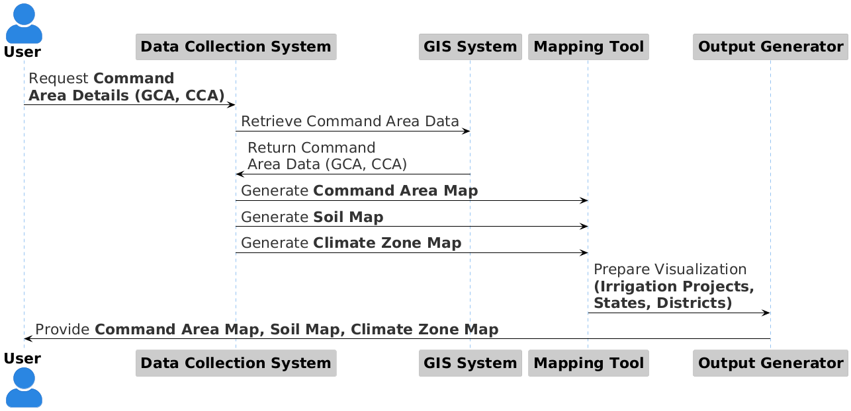

**Code For Figure 005_Visulisation_SequDiag_PlantUML**

@startuml

!theme reddress-lightblue

skinparam linetype ortho

skinparam actorstyle awesome

skinparam defaultfontsize 22

actor "**User**" as U

participant "**Data Collection System**" as DCS

participant "**GIS System**" as GIS

participant "**Mapping Tool**" as MT

participant "**Output Generator**" as OG

U -> DCS: Request **Command** \n**Area Details (GCA, CCA)**

DCS -> GIS: Retrieve Command Area Data

GIS -> DCS: Return Command \nArea Data (GCA, CCA)

DCS -> MT: Generate **Command Area Map**

DCS -> MT: Generate **Soil Map**

DCS -> MT: Generate **Climate Zone Map**

MT -> OG: Prepare Visualization \n**(Irrigation Projects,** \n**States, Districts)**

OG -> U: Provide **Command Area Map, Soil Map, Climate Zone Map**

@enduml

**2. Command Area Map on scale 1;50,000**

* **Gross Command Area (GCA)**
* Left Bank (GCA) (ha)
* Right Bank (GCA) (ha)
* Total GCA (ha)
* **Culturable Command Area (CCA)**
* Left Bank (CCA) (ha)
* Right Bank CCA (ha)
* Total CCA (ha)
* **Ratio of GCA to CCA (%)**

**Figure 006_Visulisation 2_SequDiag_PlantUML**

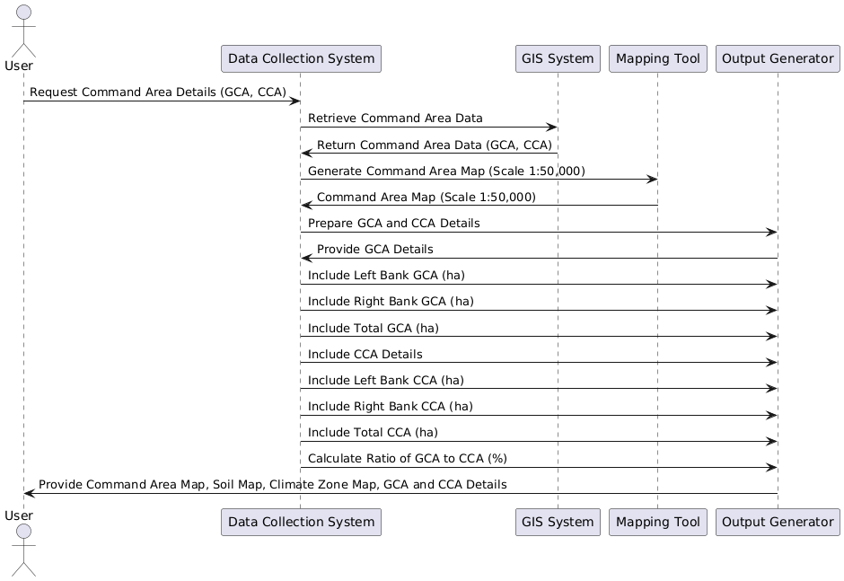

**Code For Figure 006_Visulisation 2_SequDiag_PlantUML**

@startuml

actor "User " as U

participant "Data Collection System" as DCS

participant "GIS System" as GIS

participant "Mapping Tool" as MT

participant "Output Generator" as OG

U -> DCS: Request Command Area Details (GCA, CCA)

DCS -> GIS: Retrieve Command Area Data

GIS -> DCS: Return Command Area Data (GCA, CCA)

DCS -> MT: Generate Command Area Map (Scale 1:50,000)

MT -> DCS: Command Area Map (Scale 1:50,000)

DCS -> OG: Prepare GCA and CCA Details

OG -> DCS: Provide GCA Details

DCS -> OG: Include Left Bank GCA (ha)

DCS -> OG: Include Right Bank GCA (ha)

DCS -> OG: Include Total GCA (ha)

DCS -> OG: Include CCA Details

DCS -> OG: Include Left Bank CCA (ha)

DCS -> OG: Include Right Bank CCA (ha)

DCS -> OG: Include Total CCA (ha)

DCS -> OG: Calculate Ratio of GCA to CCA (%)

OG -> U: Provide Command Area Map, Soil Map, Climate Zone Map, GCA and CCA Details

@enduml

**Figure 006_Visulisation 2_SequDiag_PlantUML**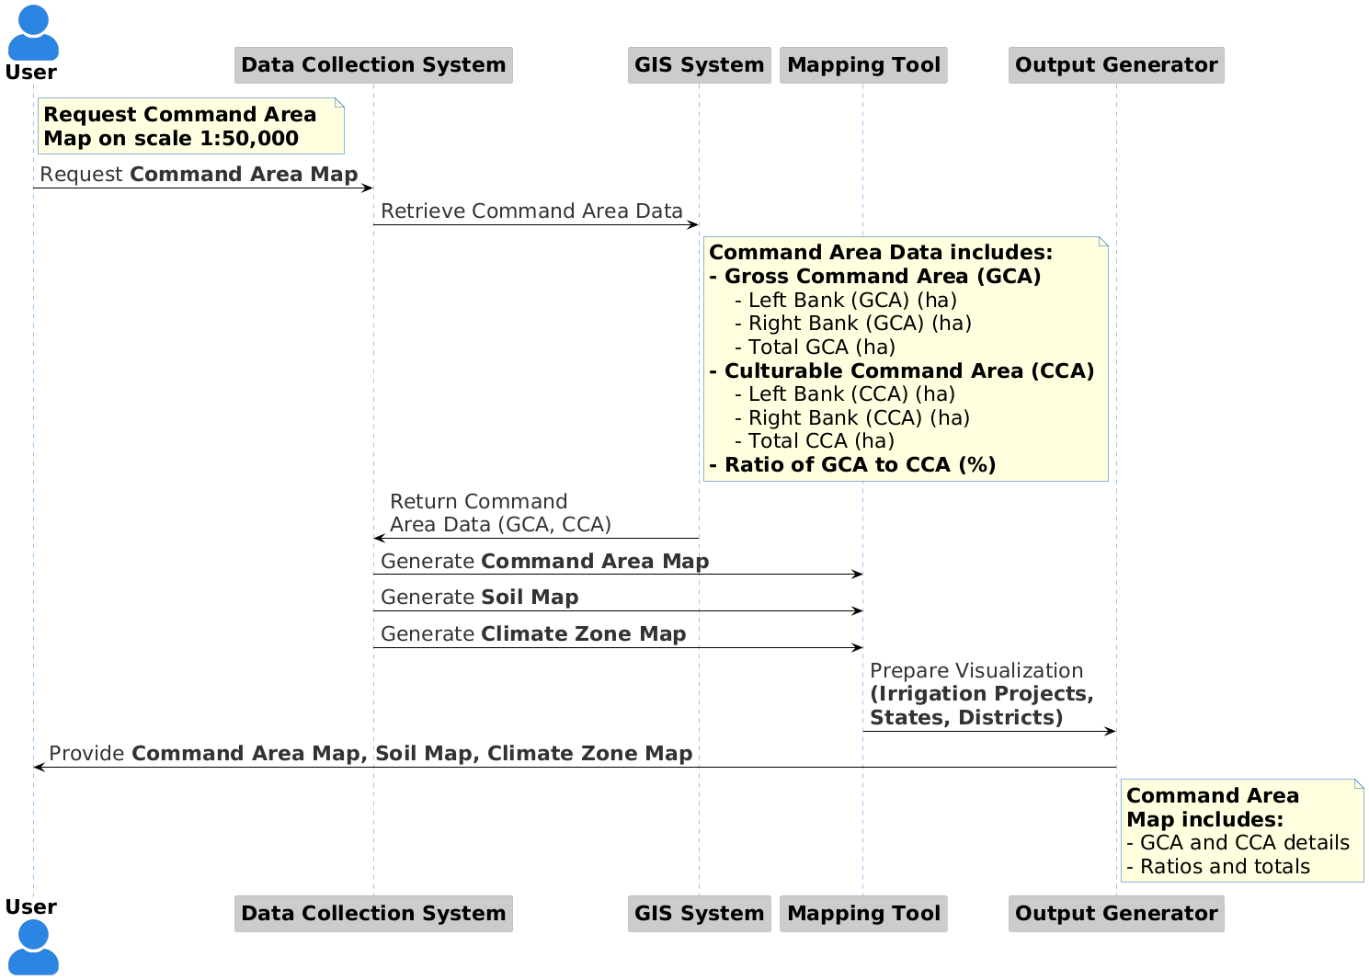

**Code For Figure 006_Visulisation 2_SequDiag_PlantUML**

@startuml

!theme reddress-lightblue

skinparam linetype ortho

skinparam actorstyle awesome

skinparam defaultfontsize 22

actor "**User**" as U

participant "**Data Collection System**" as DCS

participant "**GIS System**" as GIS

participant "**Mapping Tool**" as MT

participant "**Output Generator**" as OG

note right of U #lightyellow

**Request Command Area**

**Map on scale 1:50,000**

end note

U -> DCS: Request **Command Area Map**

DCS -> GIS: Retrieve Command Area Data

note right of GIS #lightyellow

**Command Area Data includes:**

**- Gross Command Area (GCA)**

- Left Bank (GCA) (ha)

- Right Bank (GCA) (ha)

- Total GCA (ha)

**- Culturable Command Area (CCA)**

- Left Bank (CCA) (ha)

- Right Bank (CCA) (ha)

- Total CCA (ha)

**- Ratio of GCA to CCA (%)**

end note

GIS -> DCS: Return Command \nArea Data (GCA, CCA)

DCS -> MT: Generate **Command Area Map**

DCS -> MT: Generate **Soil Map**

DCS -> MT: Generate **Climate Zone Map**

MT -> OG: Prepare Visualization \n**(Irrigation Projects,** \n**States, Districts)**

OG -> U: Provide **Command Area Map, Soil Map, Climate Zone Map**

note right of OG #lightyellow

**Command Area**

**Map includes:**

- GCA and CCA details

- Ratios and totals

end note

@enduml

**3. Soil Survey Map of Command Area on Scale 1:50000**

* **Type of Soils:**
* **Land Irritability Classifications**
* Class I Land (%)
* Class ll Land (%)
* Class Ill Land (%)
* Class IV Land (%)
* **Command Area Slope (%)**
* **Ground Water Table**
* Pre Monsoon (m)
* Post Monsoon (m)

**Figure 007_Visulisation 3_SequDiag_PlantUML**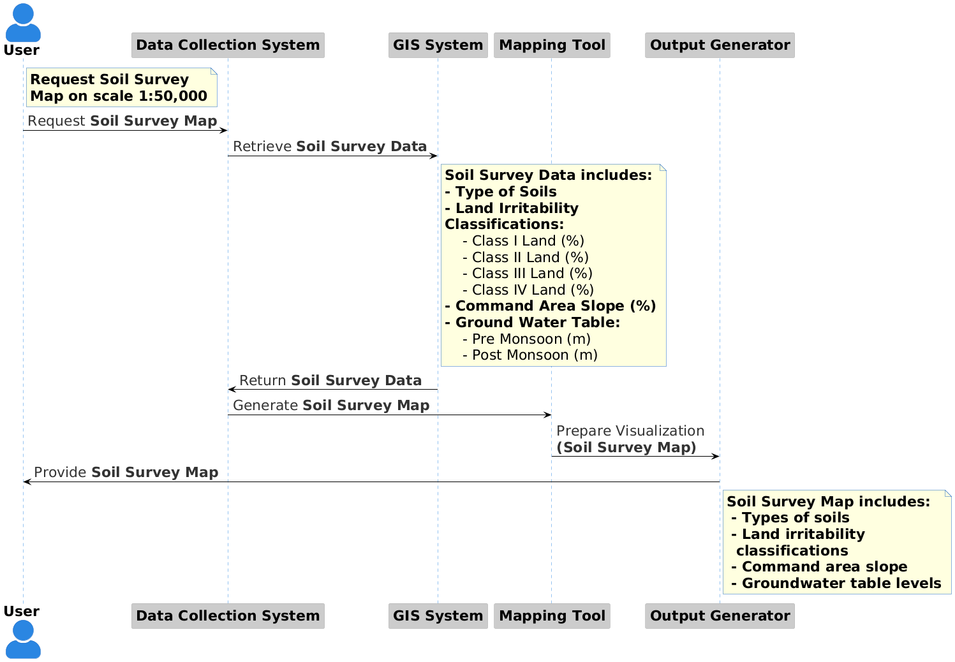

**Code For Figure 007_Visulisation 3_SequDiag_PlantUML**

@startuml

!theme reddress-lightblue

skinparam linetype ortho

skinparam actorstyle awesome

skinparam defaultfontsize 22

actor "**User**" as U

participant "**Data Collection System**" as DCS

participant "**GIS System**" as GIS

participant "**Mapping Tool**" as MT

participant "**Output Generator**" as OG

note right of U #lightyellow

**Request Soil Survey**

**Map on scale 1:50,000**

end note

U -> DCS: Request **Soil Survey Map**

DCS -> GIS: Retrieve **Soil Survey Data**

note right of GIS #lightyellow

**Soil Survey Data includes:**

**- Type of Soils**

**- Land Irritability**

**Classifications:**

- Class I Land (%)

- Class II Land (%)

- Class III Land (%)

- Class IV Land (%)

**- Command Area Slope (%)**

**- Ground Water Table:**

- Pre Monsoon (m)

- Post Monsoon (m)

end note

GIS -> DCS: Return **Soil Survey Data**

DCS -> MT: Generate **Soil Survey Map**

MT -> OG: Prepare Visualization \n**(Soil Survey Map)**

OG -> U: Provide **Soil Survey Map**

note right of OG #lightyellow

**Soil Survey Map includes:**

**- Types of soils**

**- Land irritability**

** classifications**

**- Command area slope**

**- Groundwater table levels**

end note

@enduml

**Frequency of Up-dation:-** No updation is required

**Measure of Success:-** All canals and canal structures provided in the command area function normally as per design which needs regular monitoring.

**Input Data Required:**

|  |  |  |
| --- | --- | --- |
| **Data** | **Unit** | **Type** |
| 1.Command Area Maps |  | Maps |
| 2.salient features of these structure |  | Text |
| 3.Canal Network Map |  | Decimal |
| * Length of canal | Km | Number |
| * Width of canal | m | Decimal Number |
| * Lined/unlined status of the canal | Lined/Unlined |  |
| * PIN/UGPN | Km |  |
| * Discharge through canal | M3/sec |  |
| 4.Count of conversation structure |  | Decimal Number |
| 5.Type of structure | No. | Text |
| 6. Volume(capacity) of Structure | MCM | Decimal Number |
| 7.Salient features of the conservation structures |  | Text |
| 8.Catchment area |  | Gross Capacity |
| 9.Commond area spatial layer (GIS, maps from NRSC, India WRIS, State WRD,);Hard Copy maps from state WRD/Climatic Zone map | Km2 | Live Capacity |
| 10.Name of Command |  | Dead Storage |
| 11.Type of project (Major/Medium/Minor) |  | Text |
| 12.Types of Project (Storage or Reservoir/Diversion/Lift |  | Decimal Number |
| 13.River Name/Basin transfer. | Major/Medium/Minor | Map |
| 14.Status |  | Text |
| 15.Name of the state involved | Storage | Text |
| 16.Construction under scheme | Reservoir/Diversion/Lift | Text |
| 17.Area |  | Text |
| 18.Gross command Area |  | Text |
| 19.Cultivable command area |  | Decimal Number |
| 20.Tribal Sub-plan/SC sub-plan. |  | Decimal Number |
| 21.Year of Start |  | Decimal Number |
| 22.Cost of development |  | Text |
| 23.AIBP structure like canal etc | Hectare | YYYY |
| 24.AIBP command area | Hectare | Decimal Number |
| 25.Division of schemes(head/middle/tail) | Hectare | Text |
| 26.Command area under Micro-irrigation. | Hectare | Decimal Number |
| 27.No.of WUA formed. | Hectare Middle Tail | Text |

**Process:**

**Algorithm/Tools:-**

1 Topographical survey to prepare Command areas map on 1:50000 scale showing contours at (Process flow 0.5 m interval. along with the

2. Marking Block wise GCA/CCA boundaries on Command Area map algorithm)

3. Soil map of command area to be prepared based on detailed or semi-detailed soil survey.

4. Information on data points of this use case needs to be provided by the project authorities and loaded in the software.

**Figure 008_Tools/Steps_SequDiag_PlantUML**

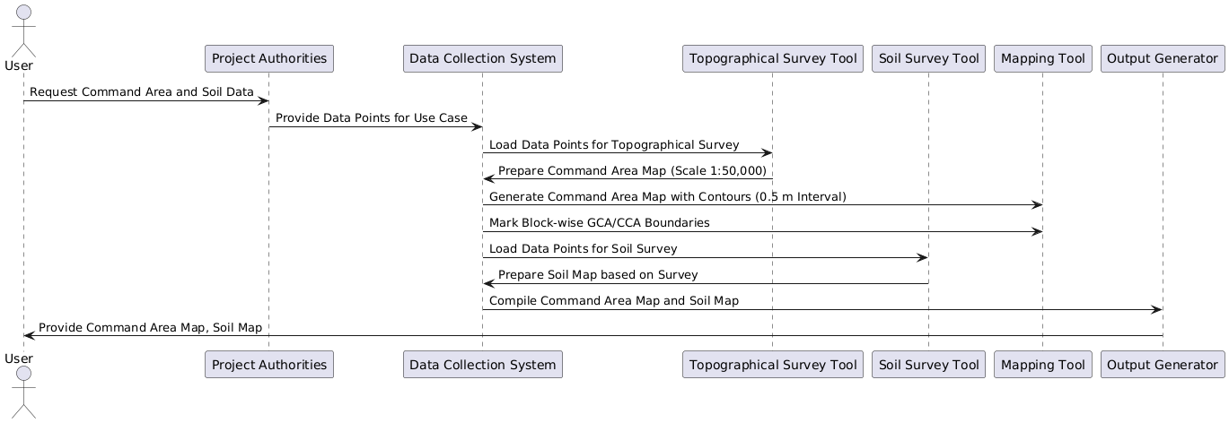

**Code For Figure 008_Tools/Steps_SequDiag_PlantUML**

@startuml

actor "User " as U

participant "Project Authorities" as PA

participant "Data Collection System" as DCS

participant "Topographical Survey Tool" as TST

participant "Soil Survey Tool" as SST

participant "Mapping Tool" as MT

participant "Output Generator" as OG

U -> PA: Request Command Area and Soil Data

PA -> DCS: Provide Data Points for Use Case

DCS -> TST: Load Data Points for Topographical Survey

TST -> DCS: Prepare Command Area Map (Scale 1:50,000)

DCS -> MT: Generate Command Area Map with Contours (0.5 m Interval)

DCS -> MT: Mark Block-wise GCA/CCA Boundaries

DCS -> SST: Load Data Points for Soil Survey

SST -> DCS: Prepare Soil Map based on Survey

DCS -> OG: Compile Command Area Map and Soil Map

OG -> U: Provide Command Area Map, Soil Map

@enduml

**Figure 008_Tools/Steps_SequDiag_PlantUML 2**

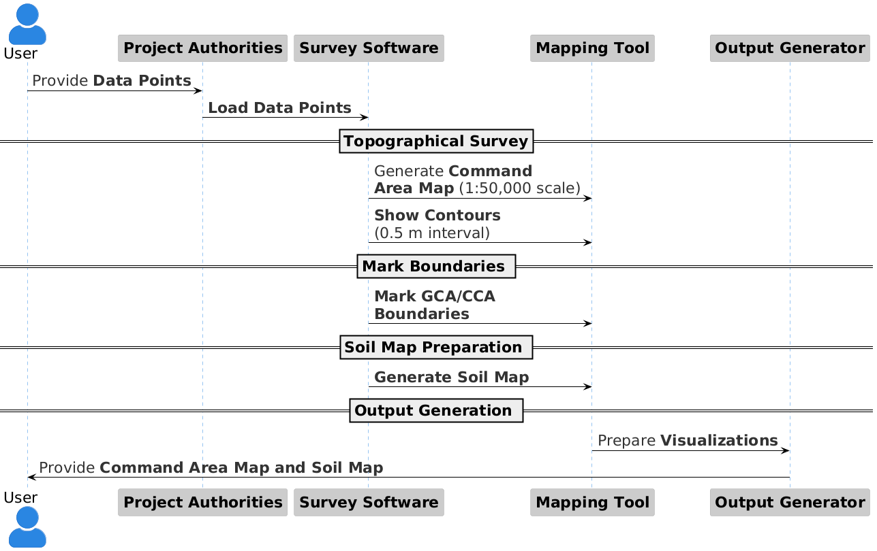

**Code For Figure 008_Tools/Steps_SequDiag_PlantUML 2**

@startuml

!theme reddress-lightblue

skinparam linetype ortho

skinparam actorstyle awesome

skinparam defaultfontsize 22

actor "User " as U

participant "**Project Authorities**" as PA

participant "**Survey Software**" as SS

participant "**Mapping Tool**" as MT

participant "**Output Generator**" as OG

U -> PA: Provide **Data Points**

PA -> SS: **Load Data Points**

==Topographical Survey==

SS -> MT: Generate **Command** \n**Area Map** (1:50,000 scale)

SS -> MT: **Show Contours** \n(0.5 m interval)

== Mark Boundaries ==

SS -> MT: **Mark GCA/CCA** \n**Boundaries**

== Soil Map Preparation ==

SS -> MT: **Generate Soil Map**

== Output Generation ==

MT -> OG: Prepare **Visualizations**

OG -> U: Provide **Command Area Map and Soil Map**

@enduml

**Figure 008_Tools/Steps_SequDiag_LucidChart**

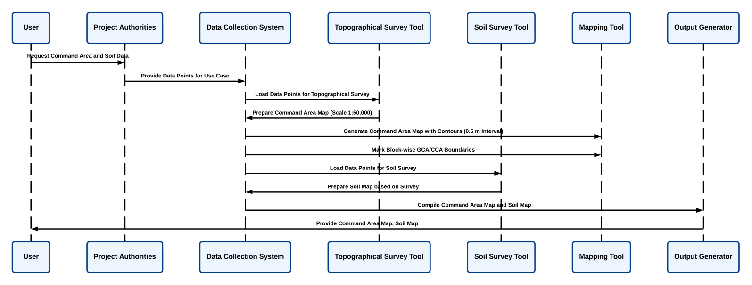

**Code For Figure 008_Tools/Steps_SequDiag_LucidChart**

@startuml

actor "User " as U

participant "Project Authorities" as PA

participant "Data Collection System" as DCS

participant "Topographical Survey Tool" as TST

participant "Soil Survey Tool" as SST

participant "Mapping Tool" as MT

participant "Output Generator" as OG

U -> PA: Request Command Area and Soil Data

PA -> DCS: Provide Data Points for Use Case

DCS -> TST: Load Data Points for Topographical Survey

TST -> DCS: Prepare Command Area Map (Scale 1:50,000)

DCS -> MT: Generate Command Area Map with Contours (0.5 m Interval)

DCS -> MT: Mark Block-wise GCA/CCA Boundaries

DCS -> SST: Load Data Points for Soil Survey

SST -> DCS: Prepare Soil Map based on Survey

DCS -> OG: Compile Command Area Map and Soil Map

OG -> U: Provide Command Area Map, Soil Map

@enduml

**Data Validation:-** Pre-validation data from irrigation project authorities will be used. No additional validation required.

**Software Technologies:-**  QGIS, QGIS Enterprise

**Dependencies & Risks/Change Management:** Data availability and permission from concerned project authority/state WRD

**User Acceptance Testing (UAT):-** CWC, State Water Resources Depth and concerned project authority

**Development Responsibility:** HARSAC

**References :- nil**

**---End of Document---**